Intelligent Production Control Scientific Methods and Research in Asset Management

Department of Mechanical Aerospace and Manufacturing Engineering, UMIST

PREVIOUS RESEARCH AND TRACK RECORD
Dr. Labib’s previous research has been geared to advancing the technological/scientific base of European automotive and other industries involved with intelligent maintenance and production control systems. The contribution of the research is summarised as follows:-
- Prior to joining UMIST, Dr. Labib was a Rockwell Research Fellow for World Class Maintenance at the University of Birmingham. He researched the design, development and implementation of a Computerised Maintenance Management System (CMMS) as part of a Rockwell Grant to the University of Birmingham. The research with Rockwell has been reported¹⁴ as a major contribution towards the improvement of the company’s competitiveness, where direct savings in production downtime have been achieved.
- He was also involved in a study with Ford – Dagenham (Control Systems Division) to investigate Programmable Logic Controllers (PLC) scan time. This work was reported¹⁹, where a new method was proposed for optimisation of PLC scan time.
- Dr. Labib has been involved in a EuroBrite Grant (ProTool) awarded to UMIST where his role was to support in the development of a Fuzzy Logic Controller for a Sheet Metal Forming Press. The development of the Fuzzy Logic Controller for Hot Point, North Wales, as part of the ProTool European project has contributed towards the competitiveness of the company, and to the efficient use of energy. This research was reported in^{7, 21}.
- Dr. Labib was invited as a Key Note Speeker on Next Generation Manufacturing Paradigms for a Workshop on Holonic Enterprises Net.ObjectDays 2002, Erfurt, Germany. He was also invited as a Key Note Speaker in the Int’l Conference on Maintenance in Process Industry, Brussels, 2002.
- Dr. Labib has been awarded two EPSRC grants (GR/M35291, and GR/M7461) to study reliability models and maintenance systems and to understand their effect on crisis management. He currently supervises 4 PhD projects and has established two research laboratories in decision-making and industrial control at UMIST.
- He has published 50-refereed papers in professional journals and proceedings of international conferences and has received two awards “Highly Commended Awards 1999 and 2000” from the Literati Club, MCB Press (a publisher of 140 journals) for published papers (Labib, 98b) and (Labib, 99c). He has been a guest editor of a special issue of the Journal of Logistics Information Management (1999) in the area of Crisis Management.
- Dr. Labib is an active member of the Department of Mechanical, Aerospace and Manufacturing Engineering at UMIST, which has been rated 5A in the past three Research Assessment Exercises (RAEs).

Introduction.
In approaching the problem of production control of complex engineering systems one can identify two broad levels for tackling the maintenance and control issues. At higher decision-making level, one is usually concerned with prioritising machines, modes of failure and types of maintenance actions that will lead to improving systems operations. These are all questions concerned with maintenance effectiveness and are of immediate particular concern to practitioners. Once the higher level questions are answered the decision-maker can address lower level decisions such as how frequently the maintenance routines should be applied. At the lower decision level, one is concerned with maintenance efficiency issues. The published work shows clearly that researchers usually address either the higher-level issues of effectiveness or the lower decisions level issues of efficiency. The partners are not aware of any published work that addresses the combined problem of maintenance management. The principle aim of this proposal is to develop an intelligent and integrated methods towards developing ‘effective’ and ‘efficient’ production control approach.

Results of investigation of the existing production and control algorithms and models (GR/M35291) show that managers lack of commitment to such models has been attributed to a number of reasons^{21, 22}: i. Managers are unaware of the various types of maintenance models, ii. A full understanding of the various models and the appropriateness of these systems to companies are not available and, iii. Managers do not have confidence in mathematical models due to their complexities and the number of unrealistic assumptions they contain. Hence, theory and implementation of existing maintenance models are to a large extent disconnected. It is concluded that there is a need to bridge the gap between theory and practice through intelligent optimisation systems. It is argued that the success of this type of research should be measured by its relevance to practical situations and by its impact on the solution of real production control problems. The developed theory must be made accessible to practitioners through information technology tools. Efforts need to be made in the data capturing area to provide necessary data for such models.

Conventional methods such as Failure Mode and Effectiveness Analysis (FMEA), Failure Tree Analysis (FTA) and Overall Equipment Effectiveness (OEE) are based on analysis of plant details in a “rigid and static ” approach. They have been successful to a degree but the volume and quality of data involved render them expensive and ineffective solutions. This proposal investigates an alternative ‘flexible and intelligent’ approach using data mining and criticality analysis on a multi-leveled and multi-axis view to focus on appropriate improvements to machines, intelligently select appropriate production control policies, and provision of specific guidance to improvement of skill levels and diagnostic techniques.

Several factors are driving the need for research that provide new, more pow

erful, analytic applications. Firstly, the amount of information available, even to quite modest organisations, continues to increase almost exponentially. What is more, there is an increasing requirement to have this data and information on hand and in real-time for decision-making. Secondly, data-life-time is diminishing as a result of the volatile markets, which are real-time in nature, and the rapid pace of business change. The initiative now is to acquire data about individual machines, based upon real interactions rather than deduced behaviour from historical data. Finally, the way that data is being accessed has changed. The days of legacy maintenance systems of large batch reports, where the focus was on data throughput, are being replaced by dynamic, on-line queries, created on-the-fly, and with answers in seconds rather than days.

In short, problems encountered with existing models are lack of:
- Accuracy; resolution quality of data.
- Relevance to shop floor realities.
- Intelligence.
- Responsiveness and Agility.

The aim of the proposed research programme is to investigate the above-mentioned problems in order to be able to understand, detect and predict changes in plants performance, hence the term Asset Management rather than just maintenance. Fundamental research will be carried out in order to establish methods for collecting data that facilitates the decision process related to the key area of Production Control in which significant ‘bottom line’ benefits can be obtained, and sustained. The objectives of the project are itemised below indicating how the milestones of the working packages will achieve those objectives.

Objectives
- Development of intelligent algorithms for accurate data capture and interpretation related to failures and preventive maintenance schedules (will be achieved through WP1).
- Investigation of methods for the assessment of production critical and mission critical systems and methods for verifying performance, including simulation of criticality in relation to total workload (will be achieved through WP2).
- Development of a generic asset management model that can help in achieving sustainable reduction in machine downtime (will be achieved through WP2).
- Testing and validation of proposed model in terms of human/computer interactions, user-centered system design, and user interface technology (will be achieved through WP3).

Those objectives will be achieved through a set of research activities described in the four work packages below with their associated milestones.

WP1 Analysis of existing data related to categorisation of failures and their eventual link to preventive schedules.
Previous work^{11,12,13,14,23} has shown that documented Preventive Maintenance (PM) schedules are not implemented because they are too static and they do not reflect shop-floor realities and needs. Moreover, they are given a lower priority than fire-fighting situations and therefore, they never get implemented. In this WP, analysis of current maintenance practice will be carried out, in terms of data capture related to fault reporting and preventive measures. Initial attempts¹³ to model generic characterisation of failures and fault codes has led to the conclusion that the majority of failures tend to be categorised into broad categories such as mechanical, electrical, hydraulic, pneumatic, and software. However, it was found that further sub-dividing of these categories will lead to industry and plant specific classifications. For example, under mechanical failures there might be axis drive, conveyor, gear box, fixture, etc. These categories will be arranged into a hierarchy of failure characterisation (Figure1). For every failure event (signature) there will be a measure of significance in terms of frequency (number of times) and downtime (duration). These combined measures will help to assign relative weights of importance to the different types of failures. Next, weights will be used to prioritise PM schedules so that existing PMs can be ranked in an adaptive way.

Knowledge of methods to categorise preventive schedules as well as failure modes will be important in designing a breakdown recording system linked to preventive maintenance databases. A technique of data mining using a prioritisation tool – the Analytic Hierarchy Process (AHP) - can help to cope with this investigation. The AHP approach has been employed in business applications to rank strategic decisions. The objective of AHP approach is to use the weights, which we call priorities, to allocate a resource among the activities. It relies on modeling a problem into a hierarchical structure of a goal, at the apex, and levels of criteria and alternatives at the bottom. The elicitation of priorities is performed using pair-wise comparison at any one level with respect to each node of upper levels in the hierarchy. The ranking of alternatives are then potential solutions to the problem. It also provides a feedback measure for consistency of comparisons.

In doing so we will be able to: add value to data collected in the form of failures categorisation (signatures), rank failure codes based on different criteria of frequency and downtime, and cross-relate characterisation of failures and their corresponding preventive maintenance schedules. The initial attempts will focus on strategic (mission critical) plants.

Milestone 1.1 Initial modelling of generic characterisation of failures, fault codes and fault patterns.
Milestone 1.2 Determination of critical parameters that will ensure swift data collection and support decision-making.
Milestone 1.3 Establishing a dynamic link of current shop-floor data to an updated PM schedules.
Milestone 1.4 Completion of modelling of the data capturing phase.

WP2 Experimental evaluation of Multiple Criteria and the Decision-Making Grid (DMG) models.

In terms of multiple criteria, the contribution of this WP is to understand the fundamental factors that constitute the production control function. An investigative experiment will be carried out where we will conduct a survey of different managers within a partner company (e.g. Federal Mogul) regarding their assessment of worst machines. They will be given the same list of existing machines (asset register). They will then be asked to rank and provide a list of the top worst performing machines from their individual point of view. As a result of this survey, information will be elicited and this will lead to the identification of different criteria of importance. The most important criteria could vary from one manager to the other. For example, downtime of bottlenecks for a production manager, frequency of calls for a maintenance manager, and spare parts cost for a finance manager. The established criteria will then be mapped into a hierarchical model. The model will be used to rank failure modes captured in Milestone 1.3 with respect to the criteria identified as a result of this experiment. In order to ensure sustainability of such an approach, a sensitivity analysis will be performed by examining the outcome of the ranking model based on variation of importance of the elicited criteria.

In terms of the Decision-Making Grid (DMG) model, this presents a concept for the categorisation of asset management policies at a more strategic level, such that maintenance actions can be applied to groupings of plants that will enable effective control of machines. Particular attention is directed to critical ones. The mechanism used for the development and presentation of this model is a DMG, which operates upon multiple criteria using fuzzy logic rule-based system (figure 2). The decision-making grid has been previously successfully deployed by Labib (UMIST)⁷ in ascribing maintenance policies to groupings of machines. Recent works of other researchers^{4, 22} have shown that the selection of maintenance and spare parts policies can be visualised and analysed using a DMG, which acts as a map where the performances of different systems are placed when measured against multiple criteria. The objective is to implement appropriate technological-based actions that will lead to the improvement of the state of those systems. At this stage we do not know exactly the dimensionality of the grid. However, the elicited information from the shop floor experts will determine the dimensionality of the DMG. For example, if in case of a two-dimension grid of criteria, say frequency of calls and downtime, then one of the rules would be “if a machine in the Grid is at Low Downtime and High Frequency then the maintenance policy is to skill level upgrade (SLU) of the operators”. This is due to the fact that maintenance on this specific machine is of relatively trivial nature i.e. visiting it a lot of times (high frequency) but spending a small amount of time in repair (low downtime) and so on. This would help in allocating resources to different maintenance policies. Fig (1) illustrates the conceptual model. The DMG model will be validated, and extended, as part of this project. The proposed model will act as a systematic framework designed to organise the research results and communicate these to industrial partners. It will also serve as a model and catalyst for change in industry. The developed model will combine fixed rules and flexible strategies which a feature that characterises the holonic concept. It will also combine both qualitative and quantitative measures. In short, there will be two input sources for the proposed model. The first input is real-time data related to machines performance. The second input is knowledge originated from shop-floor experts. This will, therefore, support the hypothesis that maintenance is a multiple criteria problem involving different stakeholders with often-conflicting objectives. It also serves to counter the current focus on maintenance costs as the sole objective of asset management function. Notably, cost-optimal solutions will be incorporated into the model, where they are deemed appropriate.
Milestone 2.1 Construction and testing of prototype of multi-levelled criticality analysis based on different axis.
Milestone 2.2 Construction and testing of a selection model of appropriate maintenance policies.
Milestone 2.3 Dynamically linking to data captured in Milestone 1.3 to models constructed in milestones 2.1 and 2.2.

WP3 Data visualisation, testing and validation of model and its effect on machines performance.
As an outcome of this project overall machines performance in terms of downtime will be improved. This is the crux of the whole proposal and therefore bears repetition: it is important to set adequate performance measures such as Mean Time Between Failures (MTBF) and Mean Time To Repair (MTTR) in order to monitor improvements in performance of assets (downtime) and skills of maintenance engineers (repair).

In this WP, research will be carried out to understand failures by focusing on severity and rate of occurrence. In terms of severity, a fundamental question is “What is failure downtime?” In other words, at what level is the deterioration of state considered to be downtime? Data captured in previous milestones will provide guidance to identification of parameters that need to be monitored in an automated approach. The usage of Condition Based Monitoring (CBM) will be investigated in order to facilitate automated data capture of selected parameters. In terms of rate of occurrence, the concept of real-time data capturing and simulation of developed models on-line will be investigated. Programmable Logic Controllers (PLCs) will be used in this process as deemed necessary.

This research activity will naturally lead to modelling and simulation of a pilot machine or a manufacturing system. There exists a research laboratory in industrial computing at UMIST where a manufacturing system production line is modelled and linked to a PLC (Programmable Logic Controller). The manufacturing system is modelled and controlled using a Supervisory Control and Data Acquisition (SCADA) system. In this research project, a pilot study for developing such a model of one of the existing studied machines will be performed, but here the novelty is to try to simulate injected failures into the modeled system. Being able to monitor and accordingly respond in real time will provide an asset management model that is adaptive to shop floor realities and needs. As Charles Darwin has expressed it succinctly: “It is not the strongest of the species that survives, nor the most intelligent, but the one most responsive to change”. In understanding failures in terms of severity and rate of occurrence, we are approaching a state of responsiveness. Also being able to understand and be ‘in control’ of failure events is one step nearer to the concepts of self-repair and self-maintenance, a desirable feature of Next Generation Manufacturing Paradigms¹.

The necessity for transforming data through intranet as an alternative method of data capturing will be examined and compared to findings of recent research in this area^{6,18,20}. Although such a transformation is not proposed as an outcome of this work, it will lay the foundation for further study into maintenance hypermedia information systems.

Milestone 3.1 Report and measurement of machine performance.
Milestone 3.2 Built database visualisation in real-time for key equipment.
Milestone 3.3 Simulate equipment failure modes within a production system.

Timeliness and Novelty
An important aspect of the research is to dynamically link current shop-floor data to adaptive preventive maintenance schedules, hence agility features are achieved. The novel implementation of intelligent selection of appropriate asset management policies will lead to reduction of waste and downtime. The development of multimedia based visualisation of machines at systems and components levels will have a significant contribution for upgrading the skill levels of machines tool operators and support of advanced diagnostics. Finally, the selection of appropriate maintenance policy will verify the Decision-Making Grid (DMG) Model and determine the relevance of associated metrics that will lead to better understanding of downtime reduction techniques. A successful outcome of the proposal would provide a significant step forward in the way that asset management problems are handled. It would also yield a deeper understanding of the problems and the circumstances under which particular asset management policies are appropriate and would help to maintain Europe’s position of excellence in this large and expanding multi-disciplinary field.

Relevance to Beneficiaries
The applications of the work are multi-disciplinary in nature and the results would have a direct bearing on asset management in many areas such as manufacturing and aerospace engineering, or decision analysis and information systems. In the engineering sector, a better understanding of manufacturing plants from shop floor data is now possible, leading to a reduction in downtime, and increased confidence in predictions of failures and their consequences. It is also intended that the results will provide useful information at the component level leading to better modelling of maintenance spare parts. Recent research¹ shows that next generation manufacturing paradigms considers maintenance modelling and simulation as an important factor.

In decision analysis and information systems, with greater emphasis now placed on criticality analysis and risk assessment, prioritisation of systems and contingency planning is becoming increasingly important to insurers of engineering equipment capital. There are also longer-term benefits in terms of the understanding of appropriate selection of asset management policies, which has always been a particularly difficult area largely owing to the lack of reliable information. In particular, we would also wish to provide improved understanding of the relationship between preventive maintenance schedules and machines’ productivity with emphasis on the role of reliability centred maintenance in optimising the effectiveness of maintenance in a manufacturing environment.

Work packages, Milestones, Deliverables and Manpower requirements:
WP1 Analysis of data related to categorisation of failures and their eventual link to preventive schedules.
Milestone 1.1 Initial modelling of generic characterisation of failures, fault codes and fault patterns.
Milestone 1.2 Determination of critical parameters that will ensure swift data collection and support decision-making.
Milestone 1.3 Establishing a dynamic link of current shop-floor data to an updated PM schedules.
Milestone 1.4 Completion of modelling of the data capturing phase.

Deliverable: Intelligent algorithms for accurate data capture and interpretation related to failures and preventive maintenance schedules.

Manpower requirements: 3 years.

WP2 Experimental evaluation of Multiple Criteria and the Decision-Making Grid (DMG) models.

Milestone 2.1 Construction and testing of prototype of multi-levelled criticality analysis based on different axis.
Milestone 2.2 Construction and testing of a selection model of appropriate maintenance policies.
Milestone 2.3 Dynamically linking to data captured in Milestone 1.3 to models constructed in milestones 2.1 and 2.2.
Deliverables:
- Generation of methods for the assessment of production critical and mission critical systems and methods for verifying performance, including simulation of criticality in relation to total workload.
- Development of a generic asset management model that can help in achieving sustainable reduction in machine downtime.

Manpower requirements: 3 years.

WP3 Data visualisation, testing and validation of model and its effect on machines performance.
Milestone 3.1 Report and measurement of machine performance.
Milestone 3.2 Built database visualisation in real-time for key equipment.
Milestone 3.3 Simulate equipment failure modes within a production system.

Deliverable: Testing and validation of proposed model in terms of human/computer interactions, user-centered system design, and user interface technology.
Manpower requirements: 2 years.

Estimated manpower cost required = £40,000 x 8 = Euro 0.5m

Equipment 4 PCs for program development £5000
Software for upgrading the UMIST systems £10000
Consumables £5000

Total budget (excluding travel) Euro 0.532 m

References
- Alvi and Labib, A.W. (2001) Selecting Next Generation Manufacturing Paradigms – An AHP Based Criticality Analysis, Proc. Of IMechE, Journal of Engineering Manufacture - Part B, 2/5.
- Ben-Daya, M., S.O. Duffuaa, A. Raouf (eds), (2001) Maintenance modelling and Optimisation, Kluwer Academic Publishers.
- Geraerds, W.M.J. (1990) The EUT Maintenance Model, IFRIM report, 90/01, Eindhoven.
- Exton, T., (2000), An Inventory Decision Analysis Module for a Computerised Maintenance Management System, Final Year Project, UMIST
- Hinduja, S., J Atkinson, D K Lau, A W Labib and P Agirrezaba (2000) An intelligent controller for improving the quality of deep drawn components, Annals of the CIRP, 49/1, Sydney, Australia.
- Kobbacy, K. A. H., N.C. Poudlove, and M.A. Harper, Towards an intelligent maintenance optimisation system, Journal of the Operational Research Society, 46/7, July, pp 831-853, 1995.
- Labib, A.W., Integrated & Interactive Appropriate Productive Maintenance, PhD thesis, University of Birmingham, 1996.
- Labib, A.W., O’Connor, R.F., and Williams, G.B.; “Formulation of an appropriate maintenance strategy using multiple criteria decision making”; Journal of Maintenance & Asset Management, 11, No. 2 pp 14-21; April 1996.
- Labib, A.W., O’Connor, R.F., and Williams, G.B.; “Deriving A Maintenance Strategy Through the Application of a Multiple Criteria Decision Making Methodology”; Lecture Notes in Economics and Mathematical Systems; No. 448; Gunter Fandel, Thomas Gal (Eds.), Springer-Verlag, pp 481-490; 1997.
- Labib, A.W.(a); “World Class Maintenance Using a Computerised Maintenance Management System”; Journal of Quality in Maintenance Engineering (JQME); MCB Press; 4/1.; pp 66-75; April 1998.
- Labib, A.W.(b); “A Logistic Approach to Managing the Millennium Information Systems Problem”, Journal of Logistics Information Management (JLIM), 11/5, pp 285-384, 1998.
- Labib, A.W., O’Connor, R.F., and Williams, G.B.; “An Effective Maintenance System Using the Analytic Hierarchy Process”; Journal of Integrated Manufacturing Systems (IMS), Vol 9; No 2.; pp 87-98; April 1998.
- Labib, A.W., Williams. G.B., and O’Connor, R.F.; “An Intelligent Maintenance Model (System): An Application of A.H.P. and a Fuzzy Logic Rule-Based Controller”; Journal of Operational Research Society (JORS); Vol 9, No 7,pp 745-757, pp 160-5682, July, 1998.
- Labib, A.W.(a), “A Framework for Benchmarking Appropriate Productive Maintenance”, Journal of Management Decisions, Vol. 37, No. 10, pp 792-800, 1999.
- Labib, A.W.(b) “Optimising Scan Time of Programmable Logic Controllers Using Multiple Criteria”, Journal of Flexible Automation and Integrated Manufacturing, Vol 6., No. 2, 1999.
- Labib, A.W. (c) “The Millennium Problem Versus the Maintenance Problem”, Journal of Logistics Information Management (JLIM), Vol 12, No 3, pp 254-259, 1999.
- Labib, A. W., J. Atkinson and S. Hinduja (2000) Analysing the Parameters in Deep Drawing Using the Analytic Hierarchy Process”, IMech E Proc. of 16th International Conference, CAPE 2000, Computer Aided Production Engineering, 7-9 August, Edinbrugh, UK.
- Prickett, P.W. (1999) An integrated approach to autonomous maintenance management Integrated Manufacturing Systems, Vol. 10 No. 4 pp. 233-242
- Raouf, A. and Ben-Daya, M. (1995) Total maintenance management: a systematic approach Journal of Quality in Maintenance Engineering, Vol. 1 No. 1 pp. 6-14
- Sherwin, D. (2000) A review of overall models for maintenance management Journal of Quality in Maintenance Engineering, Vol. 6 No. 3
- Shorrocks, P., and A.W. Labib, “Towards A Multimedia-based Decision Support System for Word Class Maintenance”, Proceedings of the 14th ARTS (Advances in Reliability Technology Symposium), IMechE, Univ. of Manchester, November, 2000.
- Shorrocks, P, “Selection of the most appropriate maintenance model using a decision support framework”, unpublished report UMIST, 2000.
- Sudiarso, A and A.W. Labib, A Fuzzy Logic Approach to an Integrated Maintenance / Production Scheduling Algorithm, International Journal of Production Research (IJPR), Vol 40, No 13 pp 3121-3138, 2002.
- Vanegas, and A.W. Labib, A FQFD model for deriving optimum targets, International Journal of Production Research (IJPR), Vol 39, No 1, pp 99-120, 2001.
- Vanegas, and A.W. Labib, Application of new fuzzy weighted average (NFWA) method to engineering design evaluation, International Journal of Production Research (IJPR), Vol 39, No. 6, pp 1147-1162, 2001.

Figure 1: A conceptual model for WP2 – Multiple criteria and DMG models (Holonic architecture)

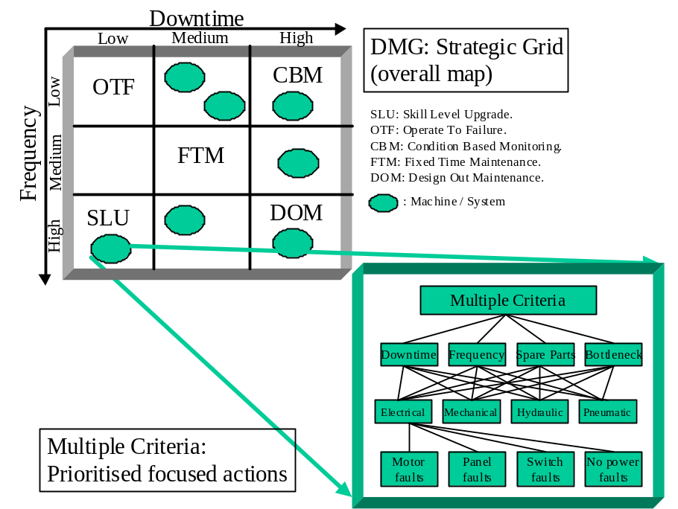

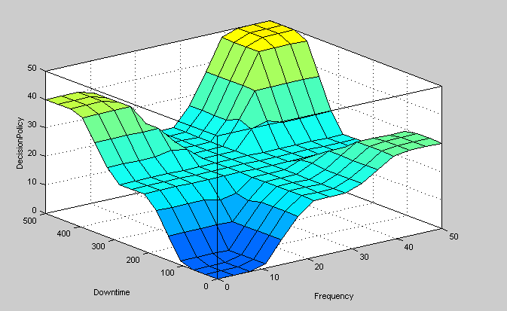
12
380
DOM
OTF
SLU
CBM
FTM
FTM

Figure 2: The Fuzzy Decision Surface Showing The Regions of Different Strategies

